**7 - Loading & Posting Timesheet - Allowances**

This process will cover you loading and posting the Timesheets and Allowances to work order, also the Monthy Expensed Work order. For **GMH Staff** your business has decided that you will put the date and the Name or Initials of the Technician in the Labour Description Box, i.e. Labour-12/12-JD. If your Work order has the Work Order Group CON INT, CON EXT, CON FMOL or CON RENTAL you should be using the Category – Servicing 1 or 2 or 3. This will also cover when you have posted labour to another business units or Branches work order, or need to split labour between different work orders and if you need to transfer to the Monthly Expensed Work order. If you have a technician working on another branches work order you will need to create a child Work order from there work order follow SOP: [5 – Create Child Work Order](https://goughgroupltd.sharepoint.com/:w:/s/GoughGroupKnowledge/EW6GqupL9TJJt8j_aCqwotsBoboTAh5Hv8OjlsZ5pGupbA?e=CL5mvJ)

1. Go to Work order management > Work orders > Time registration > Timesheet.
2. In the Show field, from the Drop-down - select **Not posted.**   
   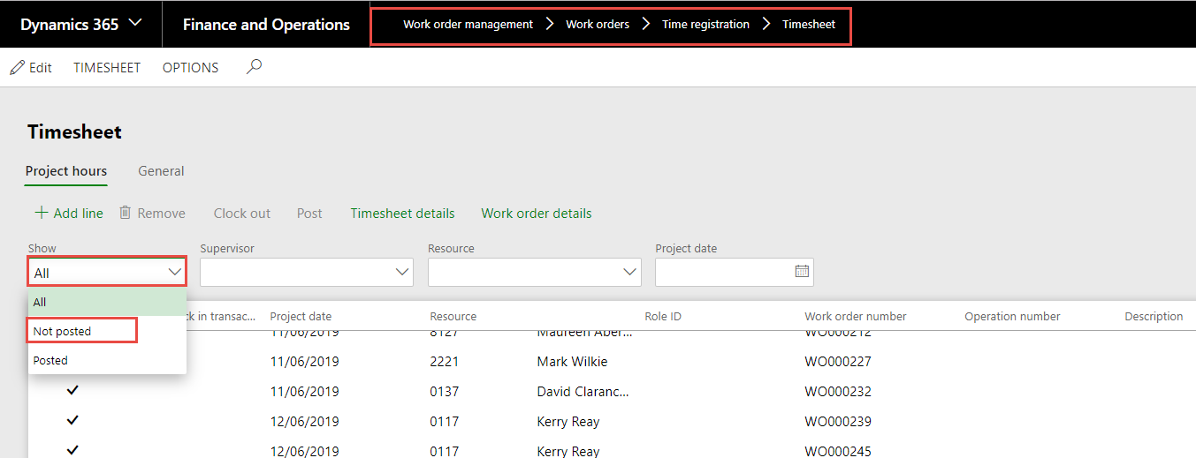
3. Resource – Select you Technician using filters.  
   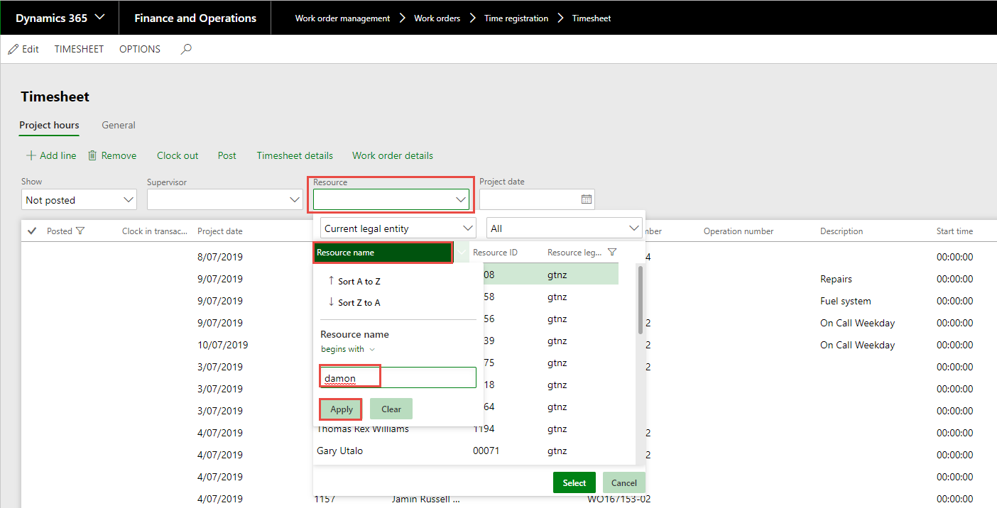
4. Select the correct Technician.  
   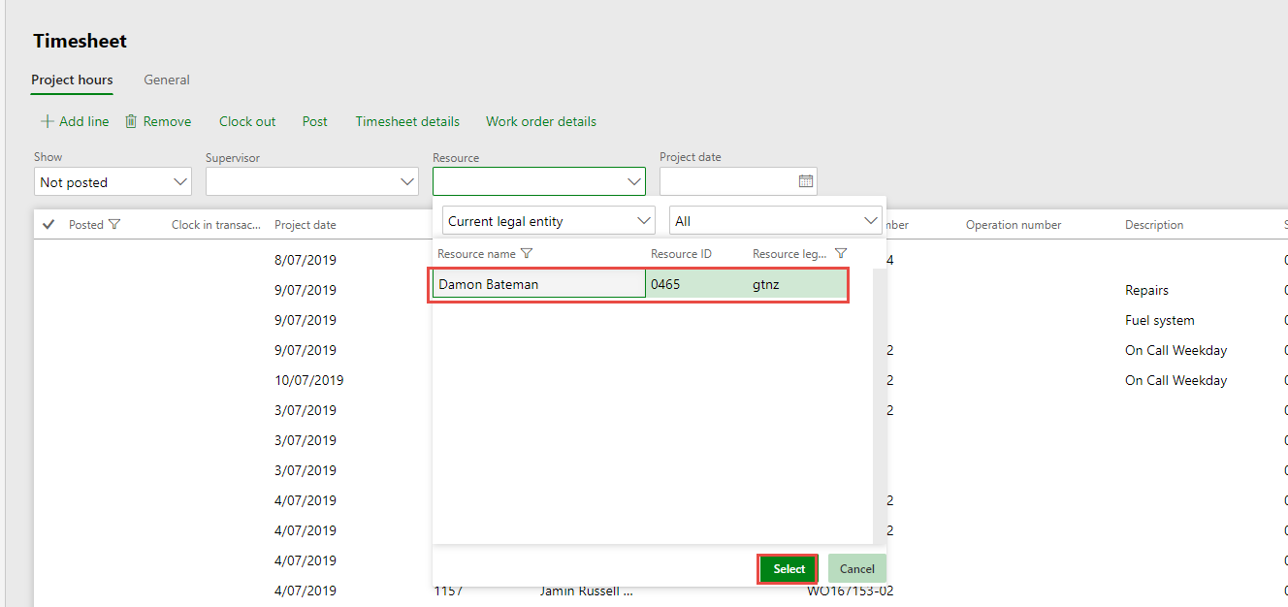
5. Add the Project date- Represents the day the work was carried out (timesheet Date). Dropdown calendar and select the correct date.  
   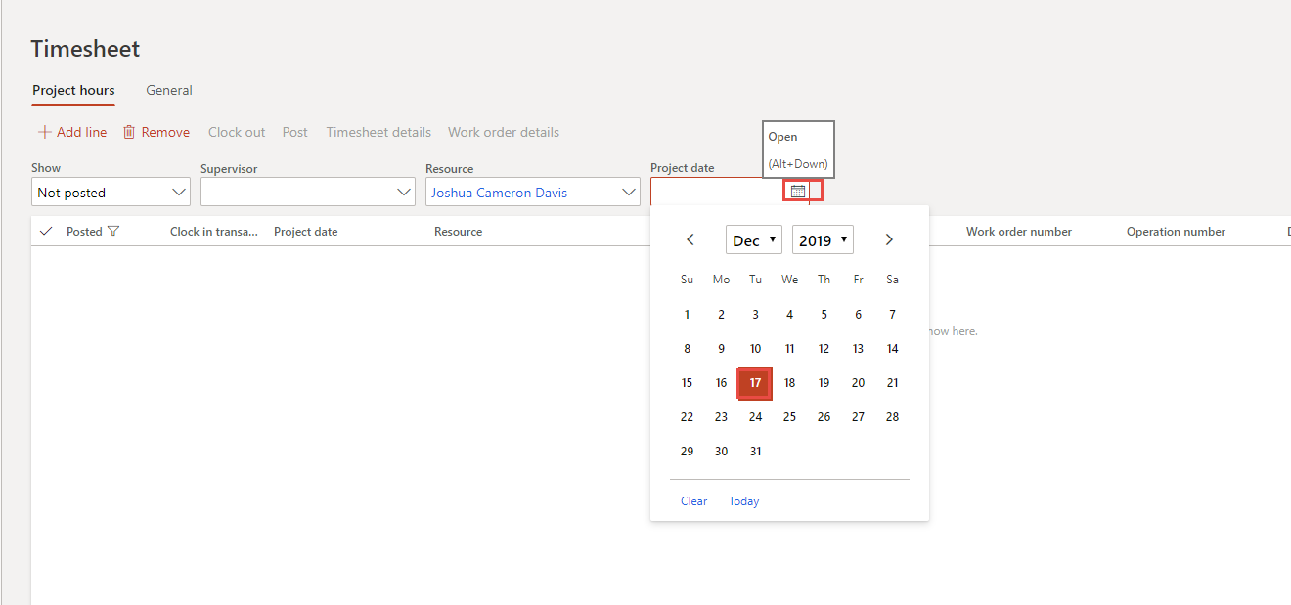
6. Select Add a Line.  
   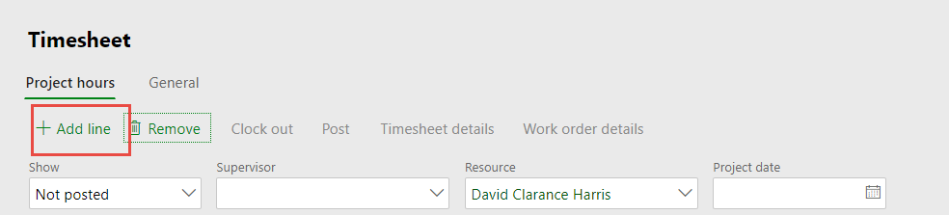
7. Work Order Number field – you can either populate it or use your filters to Select.  
   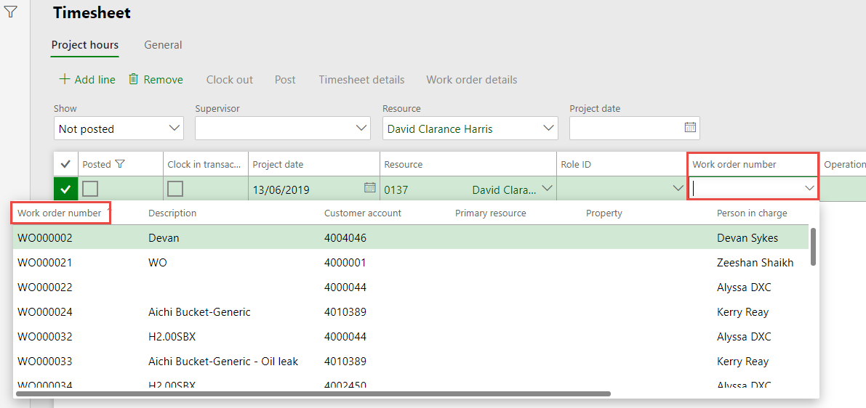
8. Description - from the time sheet – GMH you will populate the Labour, Date and the Technicican‘s name or Initials, for other business units it could represent the work order, and is optional.
9. Hours that they worked on this Work order.  
   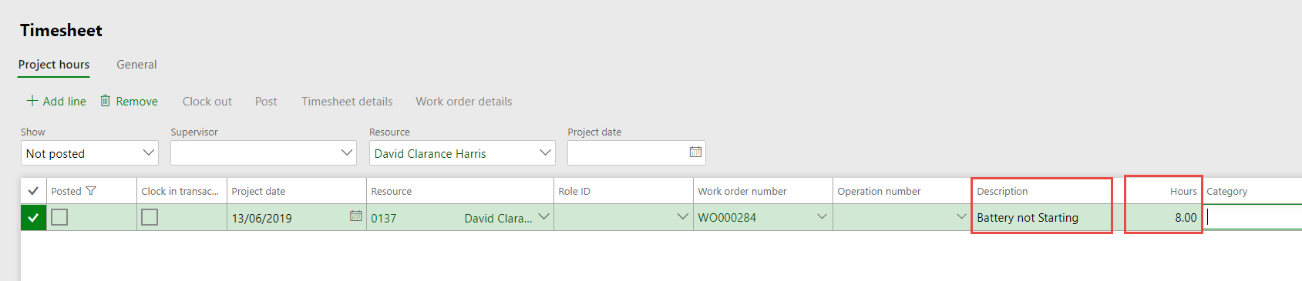
10. Category field use the drop-down list to select the correct one for the work that was completed, and whether it is normal hours or Overtime.

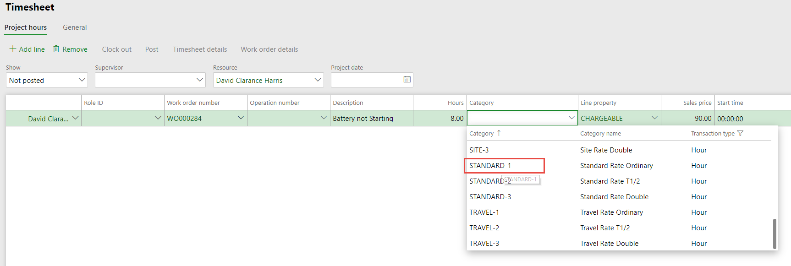

1. Line property – Should always be Chargeable – unless this Work order has the Workorder Group MOD INT in which case it will have automatically populated NON-CHARGE – Dont Change it.
2. You will also see the Sales Price of the labour.  
   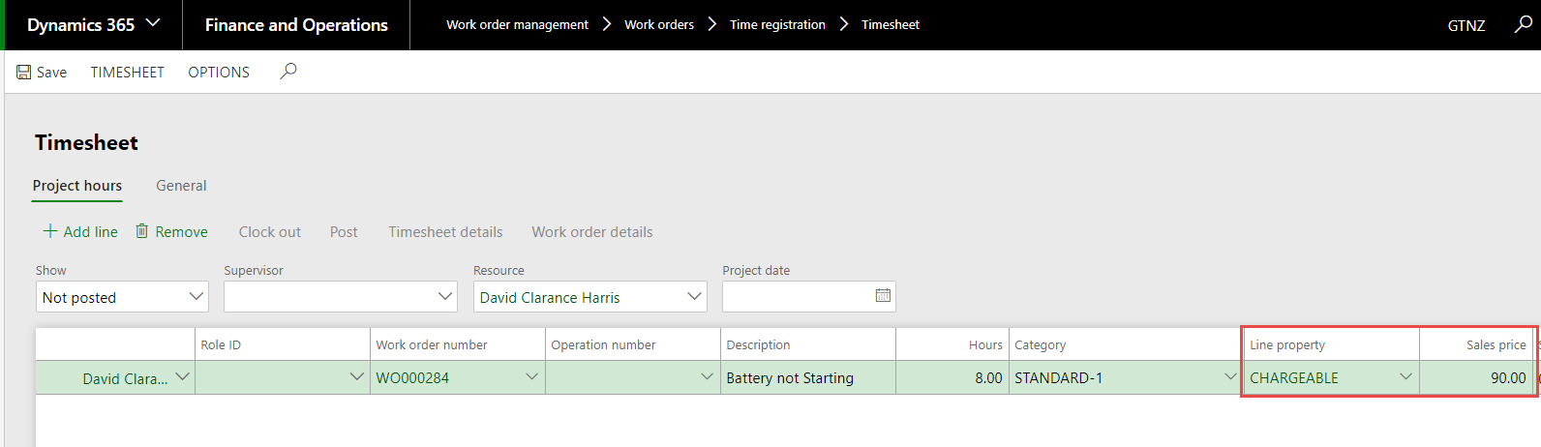
3. Continue until you have populated all of the days hours.
4. **For Expensed Labour and Allowances** that Technician gets paid but the hours and allowances are not posted to the customer‘s Work Order, we have created Workorders for each branch. These will be for the month only, new ones will be created for your Branch each month, and closed each month. You will choose either the Workorder = Allowed Time or the Child that represent lost time – Supervision etc and the allowances. For GMH a List of these and how to use them is at the end of the document.  
   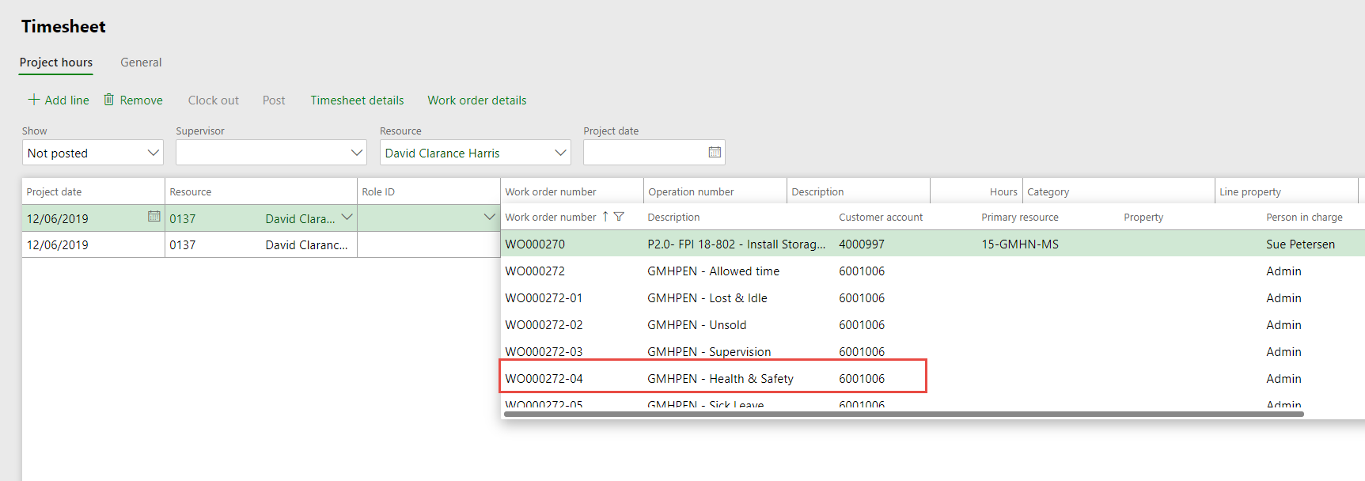
5. You continue to populate the allowances and lost time as per above filling in these fields also you should see that in some instances the Sale price is actually the cost or average price of labour.  
   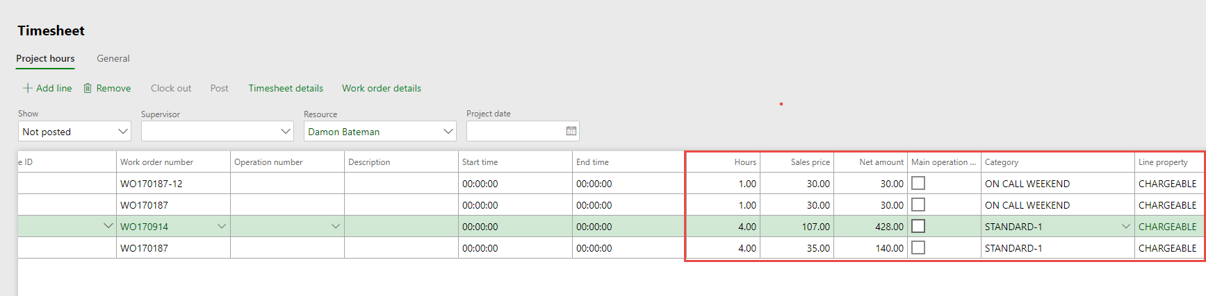
6. When Completed you will Save and Make sure that all lines are poulated. Select all lines then Post.   
   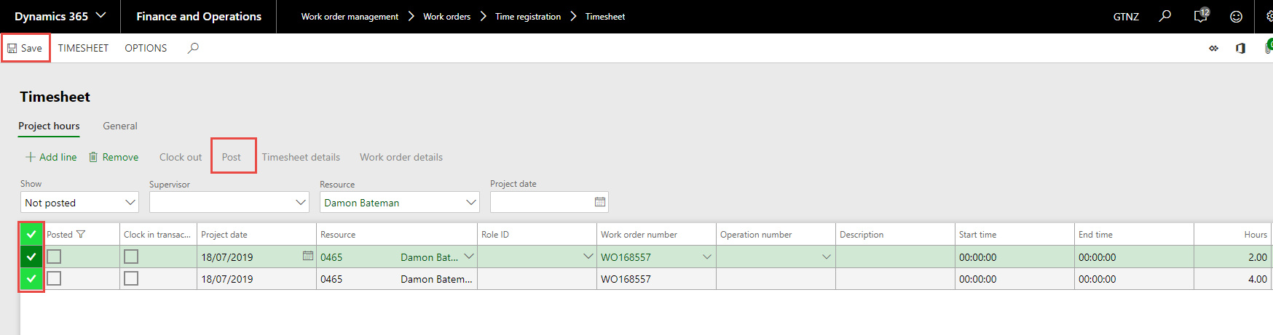
7. Post Time sheet transaction appears - Click OK.  
   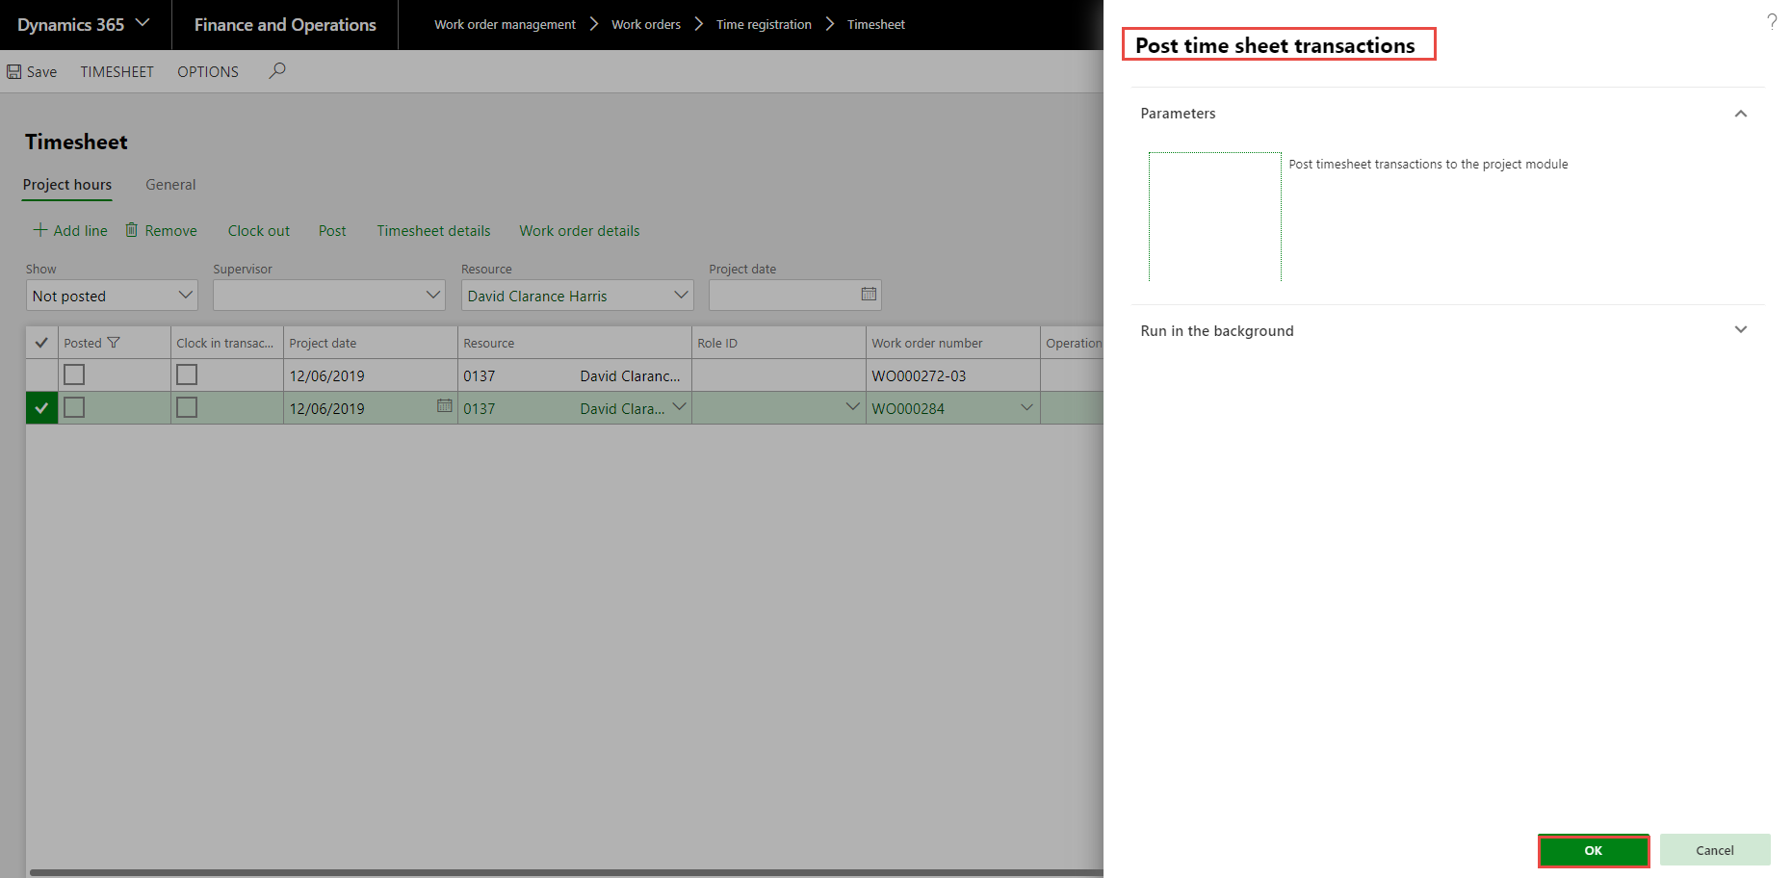
8. Repeat this for every technicians time sheets for the day.
9. To See Hour posted for that Technician.
10. Timesheet> Summary - Make sure that you have – Show as ALL or Posted Options, Resource and Date populated.  
    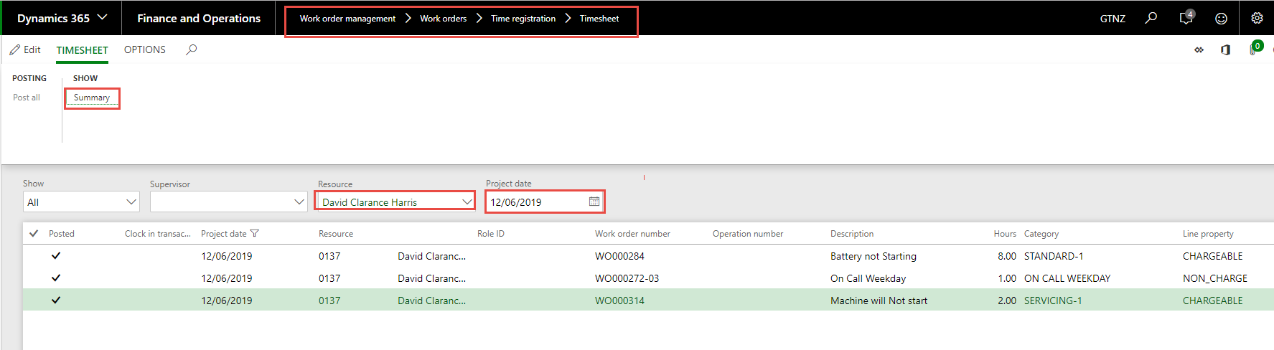
11. Inquiry comes up dont change this – Select OK.  
    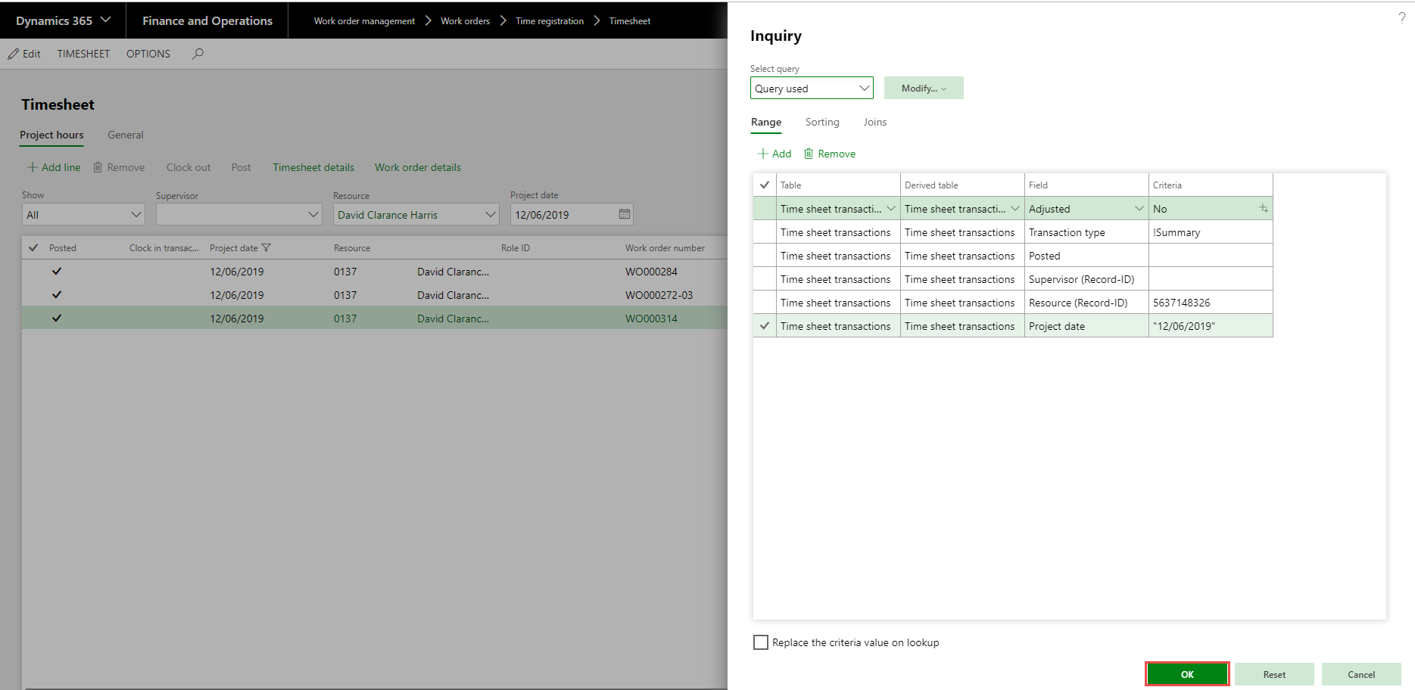
12. You see the total hours for the Technician for that Day it is Project hours you are looking for.  
    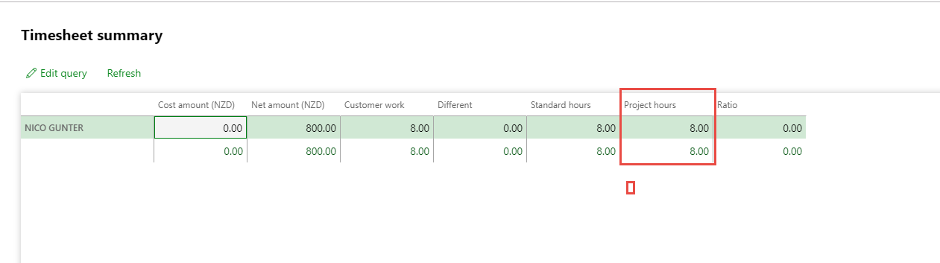
13. Close.
14. List of Expenses labour and definition.  
    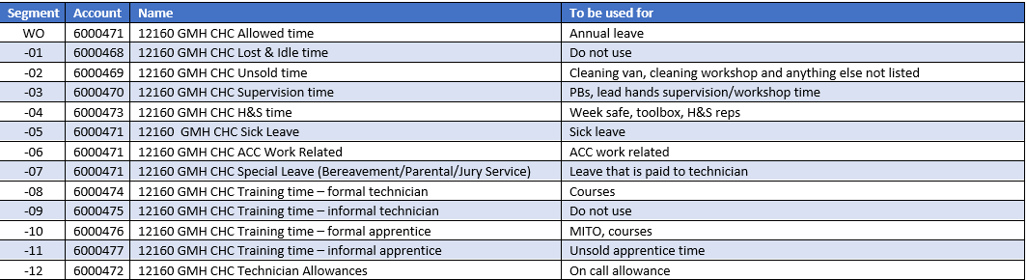

## Reversing Labour

If you have posted labour to another Business units or branch Work Order, or you need to split the posted labour between more than one Work Order or if you need to move it from one work order to the Monthly Expensed Work Order, you must reverse the original transaction. The reason you are required to do the reversal is that the above transactions effect the Labour Efficency Report.

1. Go to Work order management > Work orders > Time registration > Timesheet.
2. Filter on Posted – Resource and Date of the original labour transaction**.**   
   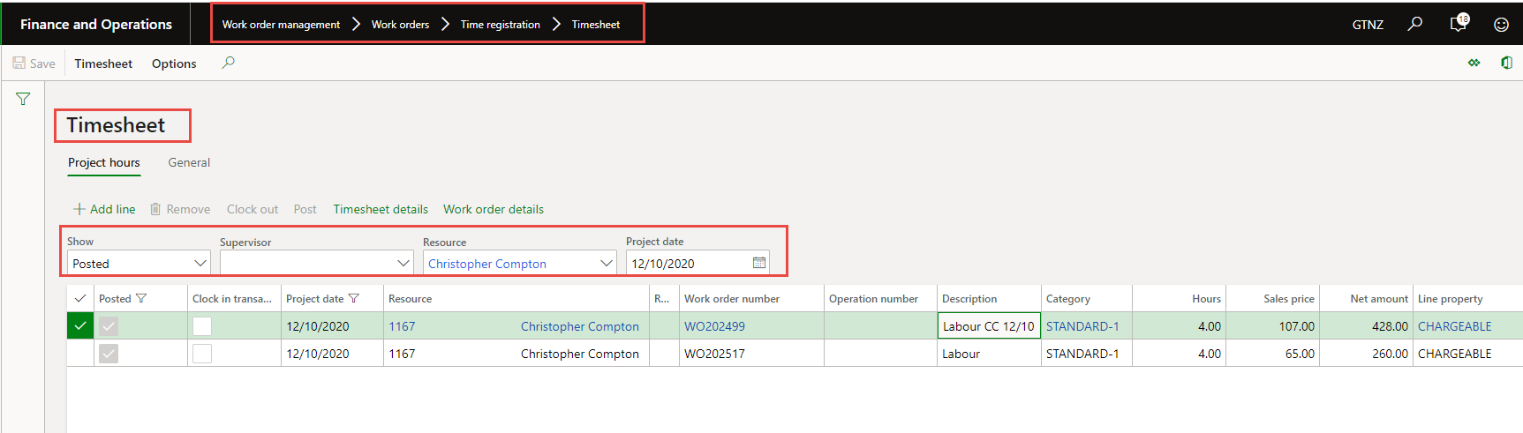
3. Create a Duplicate screen so that you can see the original transaction while you are reversing and then re populating the correct details.
4. You must reverse the total hours that went to the work order then you can either post all to correct work order or the monthly work order or split the transactions.
5. Select Not posted – resource – and date If within the same month if not todays date – select add line.  
   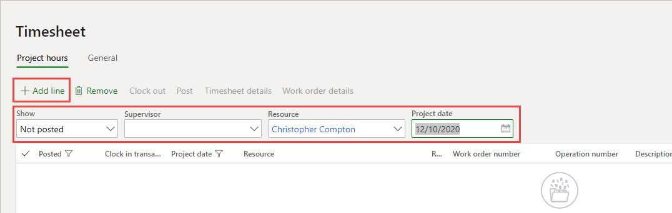
6. You populate the reversing line exactly the same as original but make sure the quantity is negative and the sale price is the same as the original.

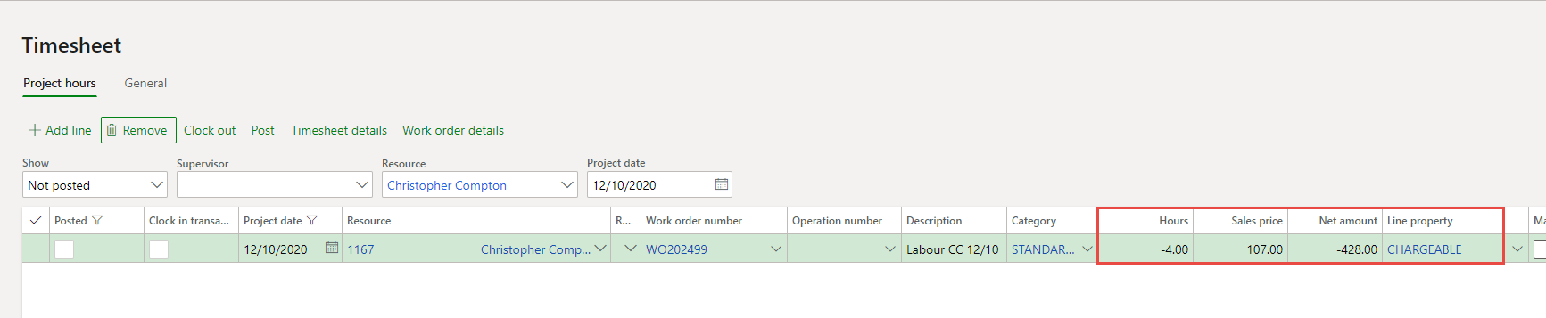

1. Select add line.
2. Now populate the work order that you want to post the labour to filling in all the details as per normal. Save.  
   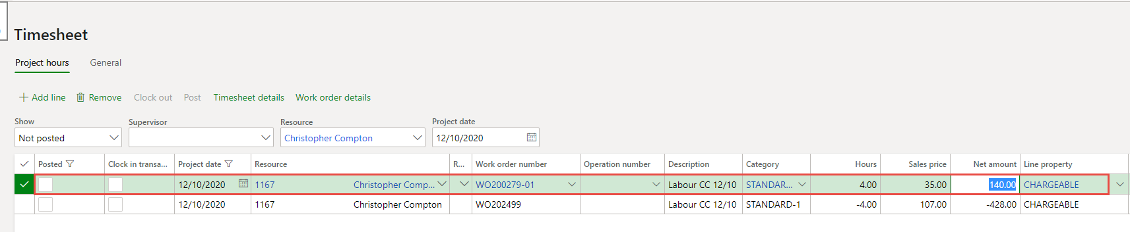
3. This show when you are reversing the hours and spliting them over a couple of work orders.  
   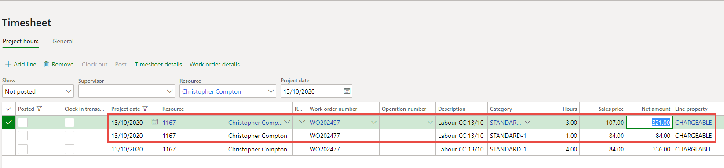
4. Now select all lines and post.

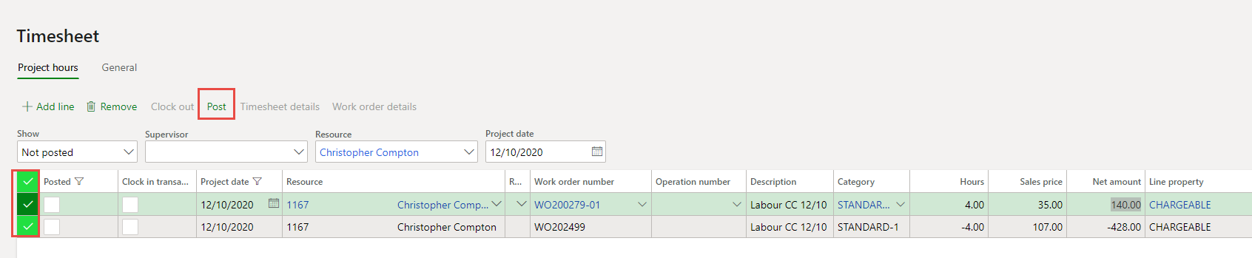

1. Select OK.

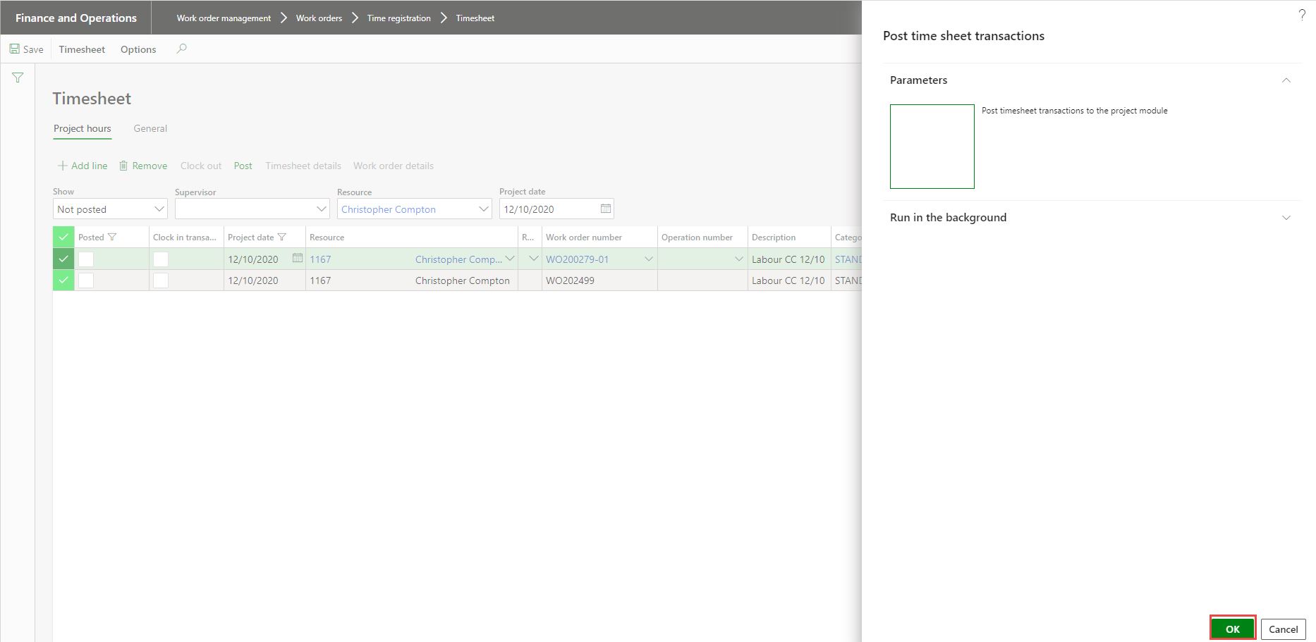

1. You get the message that the Transaction is posted.  
   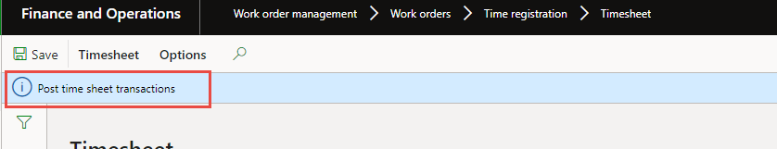
2. Close.